Casa Vietii

House of Life
October 2007

Here in Sighisoara the summer disappeared overnight replaced by icy nights and biting winds. The temperatures dropped by 20 degrees within a day. Today Sunday, October 21st it actually snowed all day. In July the weathermen said it would snow in October but growing up in England I tend not to believe everything that they say…it looks like the Romanian ones may tell the truth!

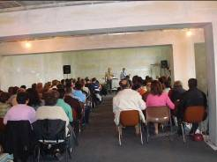
In September we were able to take part in a prophetic conference with Bob Watson from the States. The conference should have been held at a local hall in the centre of town but at the last minute they cancelled on us. Our pastor, Pilu, knew it was an attack of the enemy so he used the only other possibility for the conference - our unfinished church. It was excellent. Although the walls aren’t painted and we had a problem rigging up electric cables for the worship team and lights, the atmosphere was fantastic and our church felt like home. Please pray that the funding comes in for it to be finished soon. We need approximately $20,000 to finish it. It has been years in the planning and the building, but we are getting close and what a great way to “christen” our new church with a Prophecy Conference. As you can see from the picture, we are already outgrowing it!!

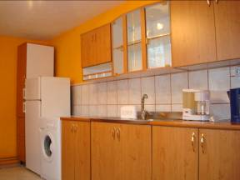
We had a great time with my sister Pam from England and with Barbara and Tommy from the states who visited us in September. Between our Yorkshire accent and Barbara’s southern accent…it was quite funny at times.

Thanks to the gifts they brought from Choose Life in Huntsville, Alabama and Barbara’s relations Brandie and Ray, we were able to buy and fit a new kitchen downstairs, change the water installation and plumbing and together with a gift from Helping Hands in England we were able to finish concreting the floors in the new medical clinic and women’s shelter building. Yea!

We’re looking forward to other visitors planned. On Oct 20th Judy and Jamie Parker are visiting from St Chads church in Romiley, England. Then, on the 1st of November Sam, Jackie, Pete and Sue will be coming on one of their regular, treasured visits to help with some construction. On the 3rd of November our dear friends Mary and Hamish are coming from Glasgow and then on the 15th of November we have our first team arriving from Hemsworth church in Yorkshire. Wow, God is blessing us with partners and dear friends.

Please pray that the weather doesn’t halt the work and that the teams have a really blessed time here. Updates in next newsletter.

The ministries in the villages are very encouraging, as many of the women have set an example by finding full time jobs. Jobs are very difficult to find and especially for the gypsies. We have no doubt that God is working in this place and we know our prayers are being answered.

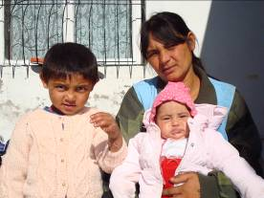
One of the ladies that calls on our help regularly is 35 yr old Irina. Irina is HIV positive. She has 5 children 13yrs, 10yrs, 8yrs, 5yrs and a little girl 4 months old. She had another girl (Roza) who died in 2001 of AIDS. Irina lived in a house that had been built for her by our friend David but her family beat her and drove her out so they could have it. She then moved into a hut in Vinatori (a village about 5 miles out of Sighi) but that burnt down. She’s now living in a plastic lean to along with all her children. With no heat for the winter it will be hard for them to exist. Her husband recently died. We’ve helped her with baby clothes, formula, then getting her paperwork sorted out so she could receive formula free from the state. We’ve bought wood for her to keep warm and this week we bought medicines for her son who had fallen on the stove and badly burnt his arm. Irina is very desperate and has lied to us many times. One example was that she brought a paper to us with the price to bury her husband. Irina can’t read or write and what she’d actually brought us was the receipt to say it had been paid by another organization. She might go to the Nazarene Church family centre and ask for money for a prescription she has in her pocket, and then she will come to us with the same request and then go to our pastor with the same request. Now we’ve got wise and when she comes we call each other to make sure the others know she’s already received the money. I often wander what I would do in her situation. To be honest, as a mother I think I would go to any lengths to make sure my kids had food and medicines they need. Please pray that some how we help her with long-term solutions to her problems. Irina represents one of many that we help each week. We have to help with their immediate physical needs, but we know that sharing the hope of Christ will care for her spiritual and eternal needs. Pray with us for God’s provision for Irina’s family and that they will see the love Christ has for them and she will receive Christ as her Saviour.

Within the team here at Casa Vietii, we believe we are on the brink of change and a turning point in our ministry. There is expectation of what God may be doing, but there are still many unknowns that have to be decided. Please pray with us to be guided by The Lord and not our own desires, that any changes are positive and only constructive for the ministry and that only God is glorified through what we do now and in the future. God is opening some doors that would help the ministry to grow, but also to help more of the women in Sighisoara and the villages. God has let us view some possibilities and we are excited, but we also know it will require His hand to see it through. We have some hindrances that need to be diminished and we need some doors to open wide with favour. Pray that we will hear His voice and only walk where He leads. Pray that the enemy would not discourage us and that our unity within the Casa Vietii Team would continue to increase. The saints always grow stronger under persecution and we know that we are growing through all of these changes.
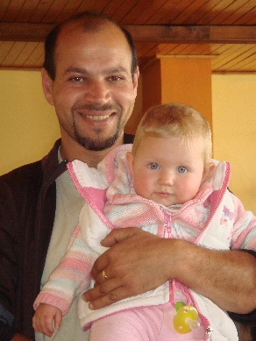
Jadyn is growing and starting to walk and talk. She is such a delight to all of her family and a trouper at adapting to the lifestyle of missionary life. Sorin enjoys being a father and she definitely has him wrapped around her little finger!

So, again, we have plenty of things to be grateful for, many answers to prayer. We have many other things to pray for. We can not do all we do without your prayers.

- Completion of Medical Clinic and Women’s Shelter including the funds to buy materials and equipment
- Safety and good weather for all the teams coming in to help with ministry
- Wisdom and discernment for making decisions on some new directions for the ministry
- Favour with officials and doctors when trying to help our ladies.
- That God would be glorified in all we do as we share the hope of Christ

Thank you so much for all your support and please don’t hesitate to contact me with any questions or comments.

Many blessings
Jill, Sorin, and Jadyn xxx

Please stay in touch. Let us know how we can pray for you. Contact us if you need any more information or if you have any suggestions. For donations to any of the projects or the operation of Casa Vietii, please contact me at jillascough@hotmail.com.

If you are in the United States,
please contact Barbara Glenn at tbglenn@bellsouth.net
or
Choose Life, Inc.
2006 Franklin Street, Suite 204
Huntsville, AL 35801
256.534.1996
www.chooselifehuntsville.org
for tax deductible donations.

